# **Business Case**:

This case study is about a company named **Blu** which has successful ventures into multiple product ranges as well as leaders in real estate business. The company’s global business head wants to use a dashboard that helps to track key metrics about their nine business unit managers (executives), products, Sales, Quantities sold, and gross margins (GM).

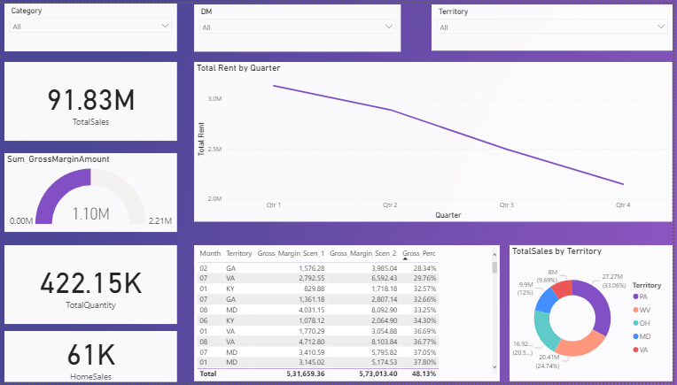

Reference Dashboard

# **Instructions**:

### #1 - ELT

Download the dataset from : <https://drive.google.com/drive/folders/1eplz7vmnNG67KECek0CUAyFaVxm4ngc2?usp=sharing> and load it to the Power BI.

Typically, Extract-Load-Transform [ELT] process is being followed.

After Extracting and Loading the dataset, transform the data as per the requirement.

1. Clean unused or erroneous rows [if there are any]
2. Fixed the datatype issues [if any]
3. Fix the other issues [if any]

### #2 - Data Modeling

As the database is normalized, we see lots of tables representing specific data points. At this point, having a proper relationship among the table is of utmost importance.

Please create the relationship among the table if there isn’t any. The final schema should look as follows,

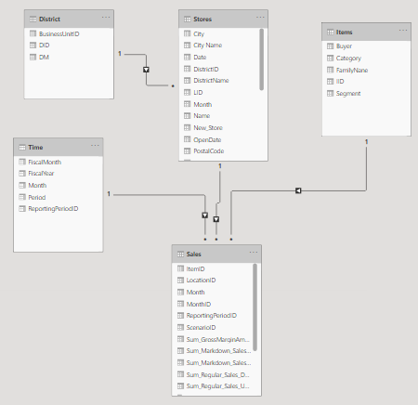

**Note**: Make sure to achieve a similar schema to get the correct results.

### #3 - Add Visual Level Filters with Slicers

Create the following slicers,



All of the options in the slicers should have multi-selection and “Select All” option.

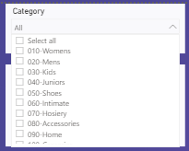

### #4 - Plot Donut Chart to display the % contribution of Gross Margin and Total Gross Margin

Create a donut chart as shown below.

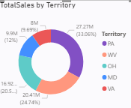

Total Sales is calculated using the below formula:

Total Sales = (Sum_Markdown_Sales_Dollars * Sum_Markdown_Sales_Units) + (Sum_Regular_Sales_Dollars * Sum_Regular_Sales_Units)

### #5 - Filter “Blank” month ID from the entire Dashboard and Ignore Negative Gross margin transactions

Don’t show the “Blank” month id in any of the visuals.

Also, Filter out the transactions with Gross margins lesser than 0 in your analysis. Only those transactions that have gross margins greater than or equal to 0 must be considered.

### #6 - Revenue and Expense Analysis

Add the following cards in your dashboard

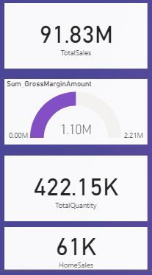

Total Quantity(Units) will be based on summation of **Sum_Markdown_Sales_Units** and **Sum_Regular_Sales_Units**.

Management has an interest analysing newly launched Home category for high margin transactions. Home sales must be calculated for total quantity sold for Home Category that has a gross margin amount greater than 10.

#7- Create the following table chart, which shows

* Sum of Gross Margin for Scenario 1
* Sum of Gross Margin for Scenario 2
* Gross Percentage

All the calculation must be based on Months of **Sales** datasheet.

Scenario 1 occurs when due to lesser inventory, all the ordered goods were not delivered to the customer.

Scenario 2 occurs when all the ordered goods were delivered to the customer, thanks to optimized inventory levels maintained.

Management wants to know that out of total gross margin availed, what percentage is due to the transactions that occurred due to Scenario 1. Thus Gross Percentage is obtained by dividing Gross Margin of Scenario 1 by Sum of Gross Margin Amount, subsequently multiplying with 100.

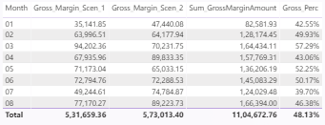

### #8 – Create a drill down capability to analyze Total rent obtained on a Time dimension

Plot the following chart as shown below :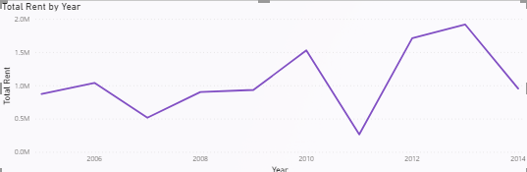

Include the drilling down capability ranging from Year – Quarter – Month level.

### #9 - Submit your work

Along with internal business stack holders, clients also will be accessing the same dashboard for continuous monitoring of the sales and other statistics. Hence, follow the theme of the dashboard as shown below and submit the working **.pbix** file for review on the google drive to be shared by you.

**PS**: The final evaluation of your Power BI exam will be done after reviewing your dashboarding skills.

